
Volume 4, No. 10 Oktober 2023
p-ISSN 2721-3854 | e-ISSN 2721-2769

STUDY OF DRAINAGE CHANNEL CAPACITY ON JALAN MASANGAN KULON SUKODONO SIDOARJO

Brian Okta Vyanto Eky Mahendra, Iwan Wahjudijanto, Novie Handajani
UPN Veteran Jawa Timur
Email: oktavyantobrian@gmail.com,iwan.ts@upnjatim.ac.id,novie.ts@upnjatim.ac,id
Abstrak:
A problem often faced by people in urban areas is flooding in residential areas during the rainy season. The causes of flood inundation include land conversion, which was originally an open area turned into a built-up area for settlements, industry or trade and offices. Land use that is not orderly causes the issue of drainage channel capacity in urban areas to be very complex. This study aims to assess the capacity of drainage channels located on Jalan Masangan Kulon so as not to hamper traffic flow and harm the activities of the surrounding community and the handling carried out to overcome flooding in the existing. The method of calculating the flood plan for this drainage case study uses the Rational Method with a 2-year return period. Data collection is done by observation, taking measurements and channel normalization. Evaluation of channel capacity is carried out to assess the ability of drainage channels to plan discharge. The results obtained in this study Flood discharge in the upstream river with a return period of 2 years amounted to 1.54 m³/second. Areas that experience flooding occur in Segments 10-17 and 18-19. In segment 10-17 the block discharge is 3.98 m³/second and the existing discharge is 3.389 m³/second. After normalizing the existing discharge is 4.34 m³ / second. In segments 18-19 the block discharge is 5.228 m³/second and the existing discharge is 4.647 m³/second. After normalizing the existing discharge is 5.760m³/second.
Keywords: Drainage,, Waterlogging, Channel Capacity, Normalization

INTRODUCTION
Population growth in Sidoarjo district, especially in urban areas, demands development development which is the cause of land use change (Arumsani et al., n.d.). Many lands that were originally open land or rice fields turned into residential and industrial areas (Qomariyah, 2019). The problem that is often faced by people in urban areas is the presence of puddles in residential areas during the rainy season (Zahouli et al., 2017). The causes of this inundation include land use change, which was originally a green open area or agriculture turned into a developed area both residential, industrial or trade and offices (Wibowo et al., 2018). Drainage systems are a very important part of urban infrastructure, so a good drainage system can free the city from stagnant rainwater, so it should not be neglected in a plan. (Asdak & Supian, 2018). Sidoarjo Regency is an area sandwiched by two large rivers, so it is known as Delta City (Muhsin, 2020). In the north it crosses the Mas River and in the south of the region, it crosses the Brantas river (Indonesia, 2018). The location of this research is located on Jalan Masangan Kulon, Sukodono, Sidoarjo. Population growth that is not balanced with the provision of adequate urban infrastructure and facilities results in irregular use of urban land (Rakuasa & Latue, 2023). This disorderly use of land is what causes drainage problems in urban areas to be very complex (Wei et al., 2023). One of the infrastructure used in question is drainage system infrastructure (RIDHO AKHMAD FIRDAUS, 2018).
This study aims to examine whether existing drainage channels can drain water runoff that occurs in drainage channels in the Masangan Kulon Street area and how to handle flooding on Masangan Kulon Street.

METHOD
The research method describes the stages of the research to be carried out, including how to collect data, calculate and analyze problems in research. In this study, the method carried out is a data collection method, both secondary and primary data. Materials and data obtained can be obtained from books, scientific writings or the internet related to research problems. The selection of research locations is on Jalan Masangan Kulon, Sukodono, Sidoarjo.
Literature Study
The literature study was conducted by looking for references to research journals related to the title of this research. Collection of every material to be studied, sourced from libraries and the internet, both in the form of softcopy and hardcopy.

RESULTS AND DISCUSSION
Hydrological Analysis
The data used to find the plan's rainfall is the maximum daily rainfall. The rainfall data used for the period 2012 to the period 2021 are in Table 1:
Table 1.Maximum Rainfall Table
No | Year | Rainfall (mm)
1 | 2012 | 87,49
2 | 2013 | 106,85
3 | 2014 | 122,22
4 | 2015 | 70,46
5 | 2016 | 143,68
6 | 2017 | 56,36
7 | 2018 | 70,11
8 | 2019 | 80,00
9 | 2020 | 68,12
10 | 2021 | 80,65
Total |  | 885,94
Average |  | 88,59
Source : Data Analysis
Distribution testing was carried out on the rainfall frequency method with the Normal, Gumbel and Log Pearson III Methods (Rasel & Islam, 2015). Based on distribution testing, it is concluded that the rainfall data that can be used for calculation is the Log Pearson III method because it has requirements that meet the following shown in Table 2:
Table 2 Distribution Test Results
Requirements of dispersion test values for various probability distribution methods
Distribusi | Parameter statistic | Result | Conclusion
Normal | Cs ≈ 0 | 1,23 | Non-Compliant
Normal | Ck = 3 | 5,26 | Non-Compliant
Gumbel | Cs = 1,14 | 1,23 | Non-Compliant
Gumbel | Ck = 5,4 | 5,26 | Non-Compliant
Log Pearson III | Cs = Flexible | 0,60 | Meet
Source : Data Analysis
After determining the distribution test of Log Person type III, then testing the suitability of the distribution function with the Chi-Square and Smirnov Kolmogorov methods (Khudri & Sadia, 2013). It was found that the fit test was acceptable on the Log Person type III distribution (Alizadeh Noughabi, 2017).
Table 3. Rainfall Calculation Log Person Type III Method
Year | K | R(mm)
2 | -0,0997 | 82,794
5 | 0,7989 | 107,739
10 | 1,3281 | 125,314
25 | 1,9389 | 149,624
50 | 2,3597 | 169,044
Source : Data Analysis

Calculation of Rainfall Intensity
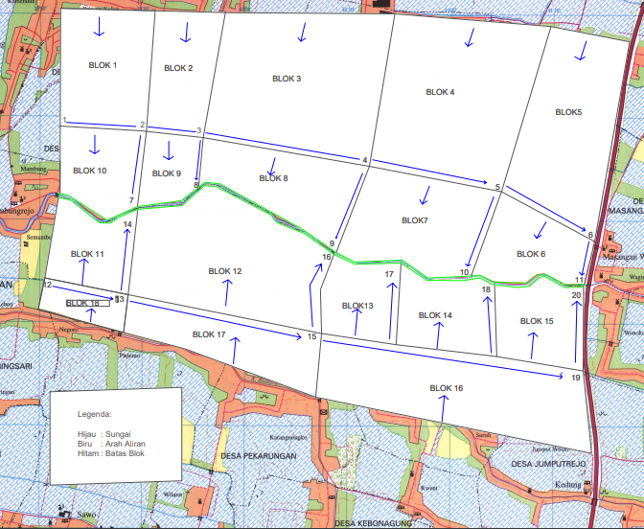
Figure 1. Masangan Kulon Street Drainage Channel Network

The catchment area taken in the case study on the Masangan Kulon road was obtained using GPS devices and using a mapping program with Google Earth. The division of regional blocks was selected based on the drainage area that flows towards the case study drainage (Pappalardo et al., 2017).
Table 4. Calculation of Rainfall Intensity
No | Blok | to (minute) | td (minute) | tc (minute) | tc (minute) | I (mm/ minute)
1 | 1 to 2 | 900,73 | 9,5 | 910,2 | 15,2 | 3,29
2 | 2 to 3 | 625,19 | 5,58 | 630,8 | 10,5 | 19,23
3 | 3 to 4 | 900,69 | 13,08 | 913,8 | 15,2 | 1,76
4 | 4 to 5 | 727,56 | 12 | 739,6 | 12,3 | 3,45
5 | 5 to 6 | 724 | 8,13 | 732,1 | 12,2 | 7,29
6 | 2 to 7 | 543,39 | 8,7 | 552,1 | 9,2 | 5,96
7 | 3 to 8 | 474,21 | 8,4 | 482,6 | 8,04 | 7,53
8 | 4 to 9 | 631,87 | 11,13 | 643 | 10,7 | 3,24
9 | 5 to 10 | 566,68 | 10,72 | 577,4 | 9,62 | 4,54
10 | 6 to 11 | 402,9 | 5,33 | 408,2 | 6,8 | 36,39
11 | 12 to 13 | 651,61 | 9,25 | 660,9 | 11 | 2,85
12 | 13 to 14 | 901,67 | 13 | 914,7 | 15,2 | 1,28
13 | 13 to 15 | 1500,63 | 18,67 | 1519 | 25,3 | 0,43
14 | 15 to 19 | 905,44 | 13,73 | 919,2 | 15,3 | 1,09
15 | 15 to 16 | 529,06 | 8,88 | 538 | 8,97 | 7,94
16 | 19 to 20 | 568,61 | 10,5 | 579,1 | 9,65 | 4,82
17 | 15 to 21 | 385 | 5,16 | 390,2 | 6,5 | 4,82
18 | 21 to 22 | 406,81 | 5,33 | 412,1 | 6,87 | 4,82
Source : Data Analysis
For the calculation of rainfall intensity using Mononobe method with a 2-year birthday. Then the calculation of channel discharge can be seen in table 5, as follows:
Table 5. Discharge Channel Plan
No | Blok | I (mm/jam) | Q (m3/det)
1 | 1 ke 2 | 3,29 | 0,118
2 | 2 ke 3 | 19,23 | 0,2
3 | 3 ke 4 | 1,76 | 0,303
4 | 4 ke 5 | 3,45 | 0,168
5 | 5 ke 6 | 7,29 | 0,232
6 | 2 ke 7 | 5,96 | 0,308
7 | 3 ke 8 | 7,53 | 0,427
8 | 4 ke 9 | 3,24 | 0,045
9 | 5 ke 10 | 4,54 | 0,069
10 | 6 ke 11 | 36,39 | 0,042
11 | 12 ke 13 | 2,85 | 0,31
12 | 13 ke 14 | 1,28 | 0,601
13 | 13 ke 15 | 0,43 | 0,281
14 | 15 ke 19 | 1,09 | 0,489
15 | 15 ke 16 | 7,94 | 0,458
16 | 19 ke 20 | 4,82 | 0,432
17 | 15 ke 21 | 4,82 | 0,232
18 | 21 ke 22 | 4,82 | 0,308
Source : Data Analysis
Table 5. Discharge Channel Plan
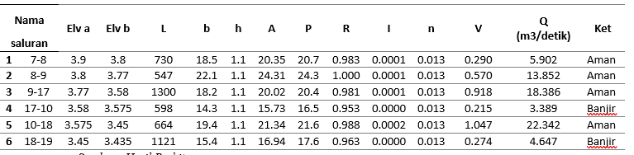
Source : Calculation Results
After calculating the discharge, it was found that in the Q17-10 segment the existing discharge value was 3.389 m3 / second while in the Q17-10 segment the block discharge value was 3.98 m3 / second and that in the Q18-19 segment the existing discharge value was 4.467 m3 / second while in the Q18-19 segment the block discharge value was 5.228 m3 / second, so there was overflow water so that the river capacity could not accommodate the discharge entering the river. Therefore, it is necessary to normalize the river.
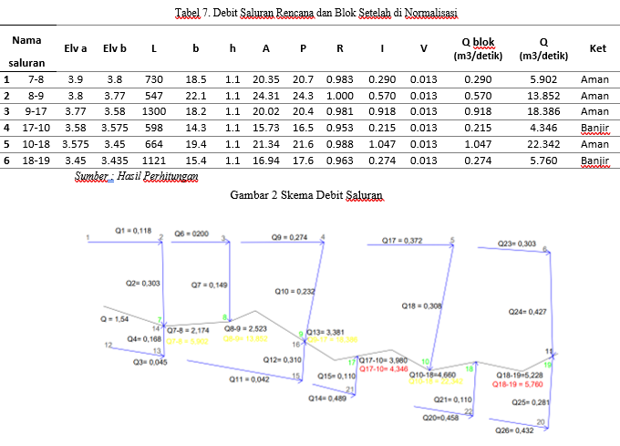
So that the results of the study enlarged channels 17-10 and 18-19 so that the capacity of the channel can accommodate the discharge from the block. From calculations, it can be seen that after normalization of the channel, there will be no more flooding.

CONCLUSION
Based on the calculation of discharge on river channels can be concluded as follows:
The calculation of upstream flood discharge with rain intensity with a 2-year birthday of 1.54 m³ / second the existing discharge value in segments 10-17 is 3.389 m3 / second while in segments 10-17 the block discharge value is 3.98 m3 / second and that in segments 18-19 the existing discharge value is 5.760 m3 / second while in segments 18-19 the block discharge value is 5.228 m3 / second. So the capacity of the channel that cannot accommodate due to the discharge in the large channel makes flooding occur in some areas passed, namely in segment channels 10-17 and 18-9. After normalization by enlarging the width of channel (b) in segments 10-17 and 19 is 18 meters and 18.8 meters with discharges of 4,346 m3 / second and 5,760 m3 / second. One form of flood control is analyzing road drainage channels. Because road drainage channels have a role in flowing water towards larger secondary channels. The results showed that the condition of the existing drainage canal was no longer qualified. Therefore, replanning of road drainage channels needs to be done so that they can collect and drain rainwater properly. In normalizing the river by expanding the width of the river channel (b) in order to accommodate the channel capacity of the block.

BIBLIOGRAFI
Alizadeh Noughabi, H. (2017). Goodness-of-fit tests for lifetime distributions based on Type II censored data. Journal of Statistical Computation and Simulation, 87(9), 1787–1798.
Arumsani, D., Santoso, I. E. B., & Reg, R. (n.d.). Factors Affecting Land Use Change of Minapolitan Area in Sedati Districts, Sidoarjo Regency.
Asdak, C., & Supian, S. (2018). Watershed management strategies for flood mitigation: A case study of Jakarta’s flooding. Weather and Climate Extremes, 21, 117–122.
Indonesia, S. (2018). Badan pusat statistik. BPS-Statistics Indonesia.
Khudri, M. M., & Sadia, F. (2013). Determination of the best fit probability distribution for annual extreme precipitation in Bangladesh. European Journal of Scientific Research, 103(3), 391–404.
Muhsin, F. A.-R. (2020). Relation between Working in Petrol Station and Blood Hemoglobin Levels for the Filling Workers in Al-Najaf City/Iraq. Indian Journal of Forensic Medicine & Toxicology, 14(2), 492.
Pappalardo, V., La Rosa, D., Campisano, A., & La Greca, P. (2017). The potential of green infrastructure application in urban runoff control for land use planning: A preliminary evaluation from a southern Italy case study. Ecosystem Services, 26, 345–354.
Qomariyah, A. N. (2019). A Pragmatic study of Jakarta Post and Jakarta Globe News headlines after Indonesian general election 2019. International Journal of Humanities, Arts and Social Sciences, 5(4), 128.
Rakuasa, H., & Latue, P. C. (2023). Monitoring Urban Sprawl in Ambon City Using Google Earth Engine: Memantau Urban Sprawl di Kota Ambon Menggunakan Mesin Google Earth. MULTIPLE: Journal of Global and Multidisciplinary, 1(2), 88–100.
Rasel, M. M., & Islam, M. M. (2015). Generation of rainfall intensity-duration-frequency relationship for North-Western Region in Bangladesh. IOSR Journal of Environmental Science, Toxicology and Food Technology, 9(9), 41–47.
RIDHO AKHMAD FIRDAUS, R. A. F. (2018). KAJIAN SALURAN DRAINASE PRECAST JALAN RB SIAIGAN KELURAHAN PASIR PUTIH KECAMATAN JAMBI SELATAN. UNIVERSITAS BATANGHARI.
Wei, P., Liu, Y., Yan, J., Li, M., & Zhang, Y. (2023). Circulation of Development Factors Promoted by Innovation of Land Management Under Background of Rural Vitalization: A Case Study of Tengtou Village in Zhejiang Province, China. Chinese Geographical Science, 33(5), 813–832.
Wibowo, S., Buvé, C., Hendrickx, M., Van Loey, A., & Grauwet, T. (2018). Integrated science-based approach to study quality changes of shelf-stable food products during storage: A proof of concept on orange and mango juices. Trends in Food Science & Technology, 73, 76–86.
Zahouli, J. B. Z., Koudou, B. G., Müller, P., Malone, D., Tano, Y., & Utzinger, J. (2017). Urbanization is a main driver for the larval ecology of Aedes mosquitoes in arbovirus-endemic settings in south-eastern Côte d’Ivoire. PLoS Neglected Tropical Diseases, 11(7), e0005751.

Copyright holder:
Brian Okta Vyanto Eky Mahendra (2023)
First publication right:
Jurnal Syntax Transformation
This article is licensed under:

